# TOPIC : SMART FARMER – IOT ENABLED APPLICATION

# SPRINT 3

|  |  |
| --- | --- |
| Team ID | PNT2022TMID33194 |

**Creating Mobile app using MIT app Inventor SMART FARMER APPLICATION**

App Inventor + IoT can work together to help us understand, and change, our everyday lives.

# Blocks

**QR CODE FOR APK DOWNLOAD:**

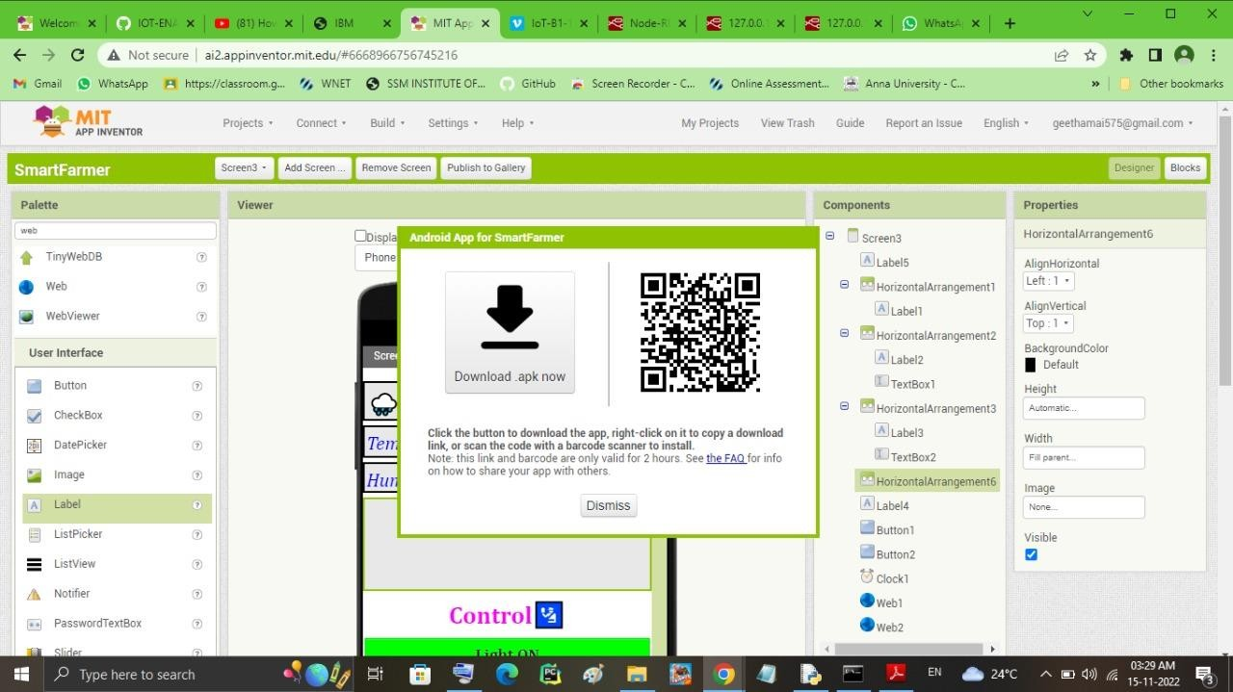

REGISTRATION AND LOGIN SCREEN :

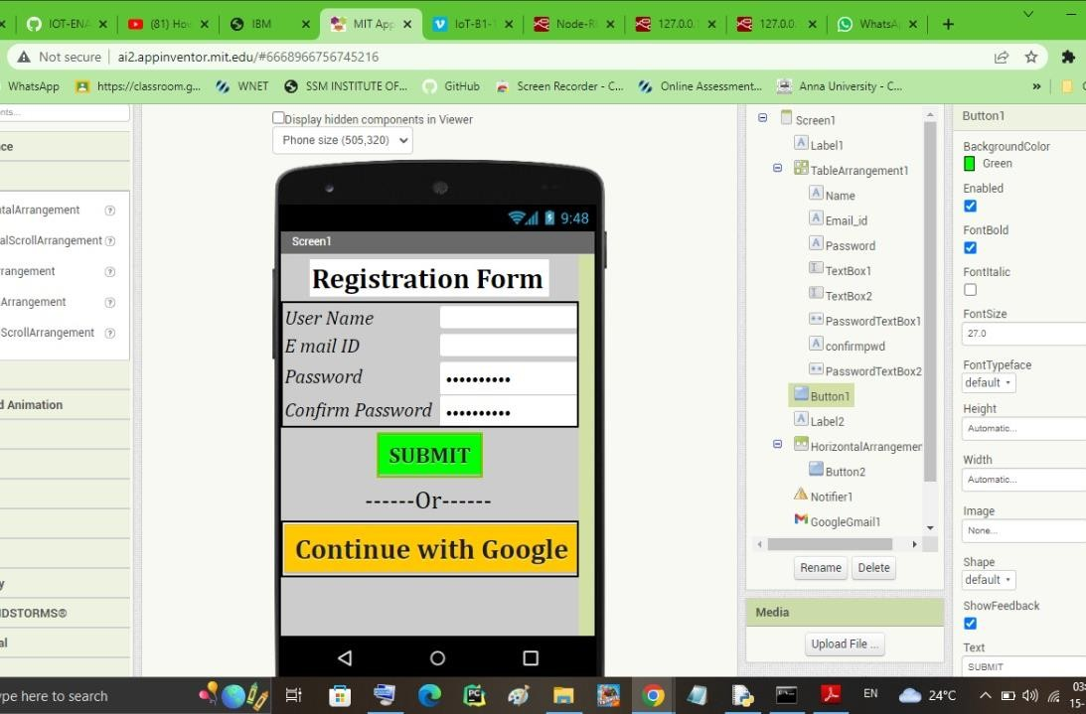

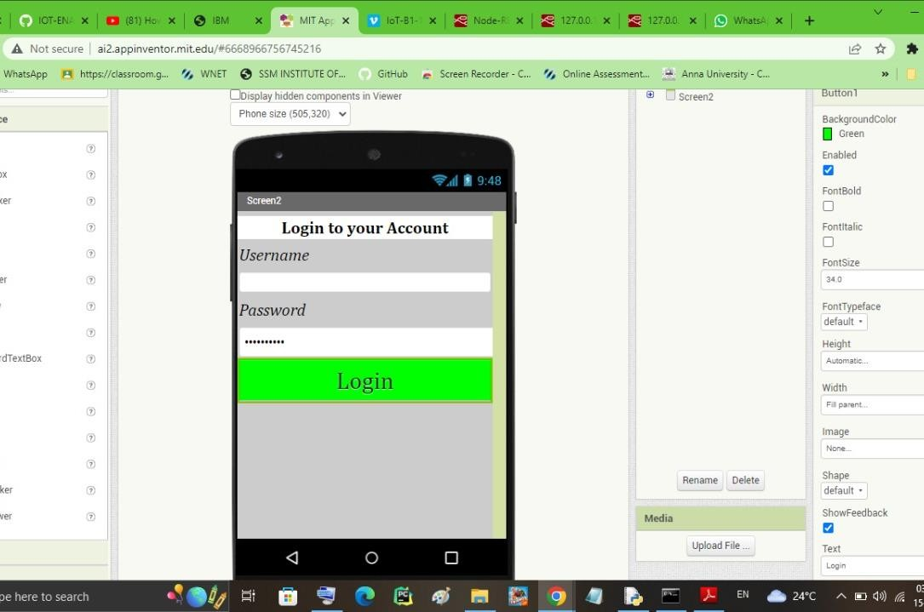

**OUTPUT SCREEN:**

